# Remote Databases - Exercise

Problems for exercises and homework for the ["JavaScript Applications" course @ SoftUni](https://softuni.bg/courses/js-apps).

For this exercuse you have to create a new application at [kinvey.com](https://console.kinvey.com/login). And for each of the following tasks you must create a **different** **collection**.

1. **Create "Books" REST Service**

Create a collection called books where each book have title, author, isbn.

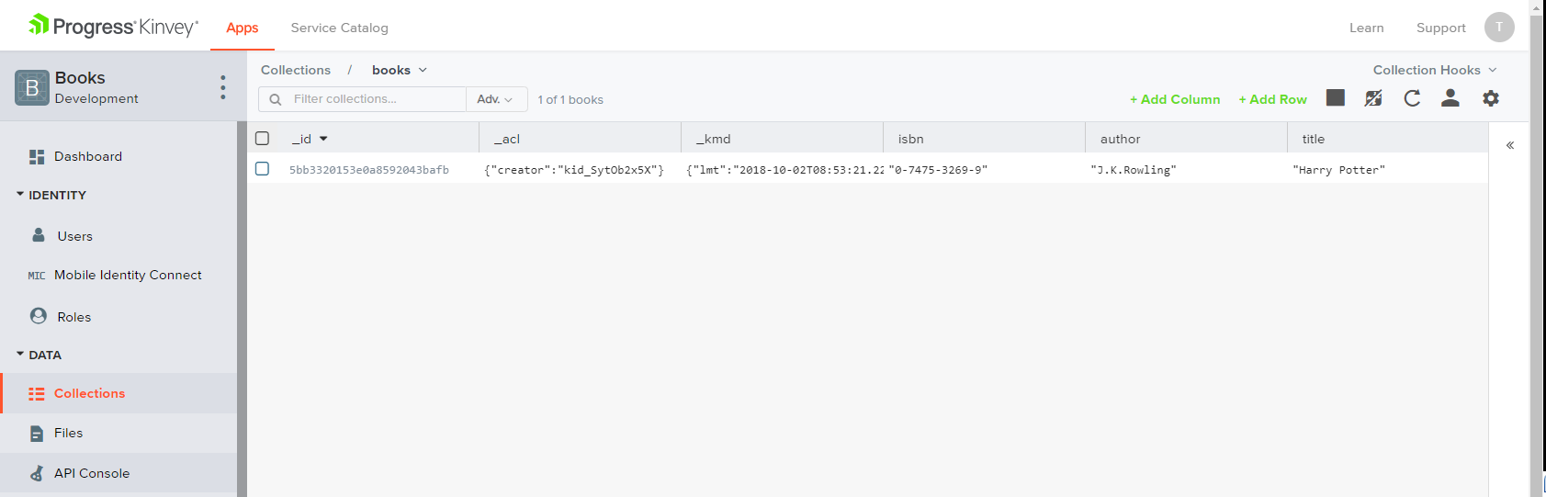

The following REST services will be created automatically to access your data:

* **List All Books**
  + Endpoint: [https://baas.kinvey.com/appdata/[:appId]/books](https://baas.kinvey.com/apdata/%5b:appId%5d/books)
  + Method: GET
  + Headers:
    - Basic Authorization with **user credentials**
  + Returns (JSON)
* **Create a New Book**
  + Endpoint: [https://baas.kinvey.com/appdata/[:appId]/books](https://baas.kinvey.com/apdata/%5b:appId%5d/books)
  + Method: POST
  + Headers:
    - Basic Authorization with **user credentials**
    - Content-type: application/json
  + Request body (JSON): {"title":"…", "author":"…", "isbn":"…"}
* **Update a Book**
  + Endpoint: [https://baas.kinvey.com/appdata/[:appId]/books/[:bookId]](https://baas.kinvey.com/apdata/%5b:appId%5d/books/%5b:bookId%5d)
  + Method: PUT
  + Headers:
    - Basic Authorization with **user credentials**
    - Content-type: application/json
  + Request body (JSON): {"title":"…", "author":"…", "isbn":"…"}
* **Delete a Book**
  + Endpoint: [https://baas.kinvey.com/appdata/[:appId]/books/[:bookId]](https://baas.kinvey.com/apdata/%5b:appId%5d/books/%5b:bookId%5d)
  + Method: DELETE
  + Headers:
    - Basic Authorization with **user credentials**
    - Content-type: application/json

Test your REST Service, e.g. using Postman. Try to list all books in JSON format with an HTTP GET request to the REST API.

**List All Books**

Use the skeleton provided in resources folder. Add an AJAX call that takes all books from your application as JSON object and displays them when the page loads.

**Create a Book**

Add an HTML form with [Submit] button for adding a new book. When the button is **pressed**, create a **new book** using its REST API with an AJAX request.

**Edit a Book**

Implement "Edit a Book" functionality. Clicking on a book should **load its data** in an HTML form. By **clicking** the [Edit] button, the **book data** should be **updated** at the **server side** with an AJAX request.

**Delete a Book**

Implement "Delete a Book" functionality. Each book should have a **[**Delete**]** button. Clicking on it should **delete the book at the server side** with an AJAX request.

**\* Add Tags for Each Book**

Implement tags for the books. Tags should be stored at kinvey in the Book collection in a column "tags" as array of strings. List the tags for each book. Implement add / edit / delete for tags when a book is created / updated.

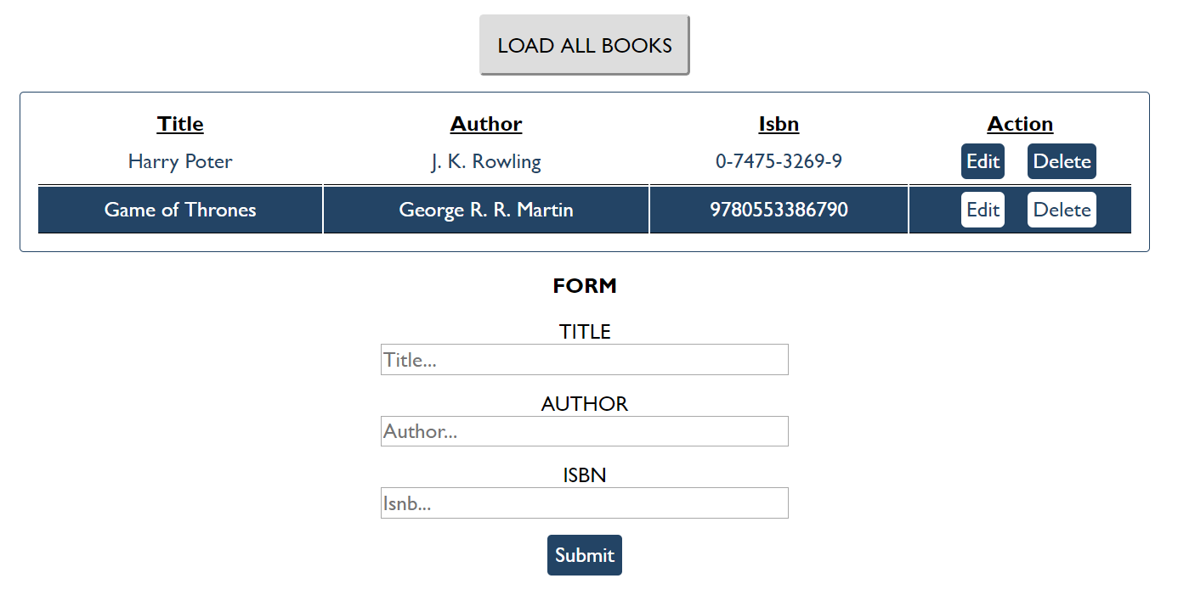

1. **Students**

Your task is to create functionality for creating and listing students from a database in Kinvey. Create a new collection called "**students**",

Each student has:

* ID - number, non-empty
* FirstName - string, non-empty
* LastName - string, non-empty
* FacultyNumber - string of numbers, non-empty
* Grade - number, non-empty

You need to write functionality for creating students. When creating a new student, make sure you name the properties accordingly. Create at least one student to test your code.

You will also need to extract students. You will be given an HTML template with a table in it. Create an AJAX request that extracts all the students. Upon fetching all students from the database, add them to the table each on a new row, **sorted** in ascending order by ID.

Use the skeleton from the provided resources.

**Screenshots**

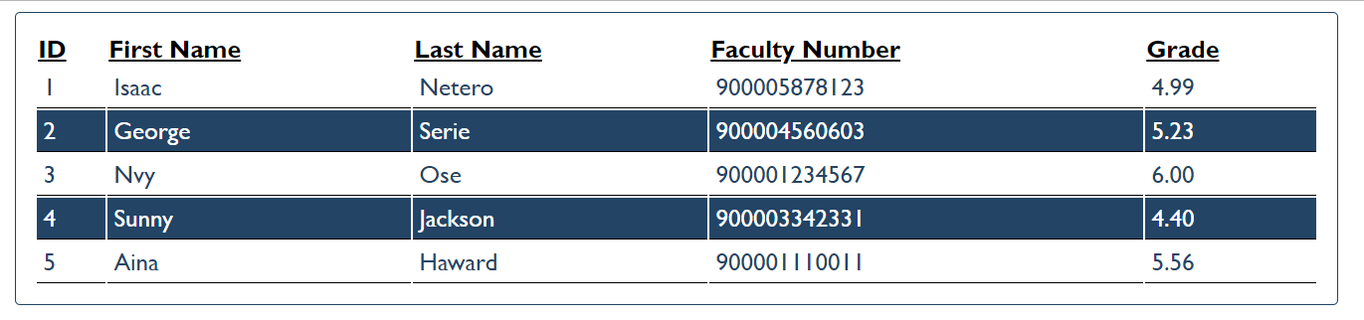

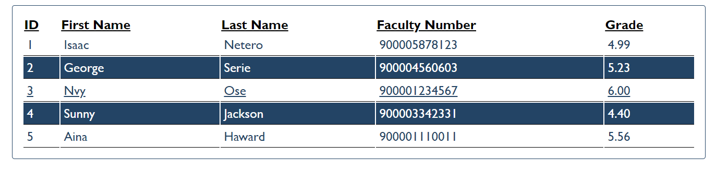

1. **Venuemaster**

Write a program that displays information about venues and allows the user to buy a ticket.

Use the skeleton from the provided resources.

You can use the following Kinvey database and credentials:

App ID: kid_BJ_Ke8hZg

User: guest

Password: pass

When the user clicks on the button with ID "getVenues", take the value of the input field with ID "venueDate" and make a POST request to: rpc/kid_BJ_Ke8hZg/custom/calendar?query={date} .

The server will respond with an array, containing the IDs of all available venues for that date. Use those IDs to obtain information from the server about **each** of the venues - make a GET request to: appdata/kid_BJ_Ke8hZg/venues/{_id}.

The server will respond with an object in the following format:

{

name: *String*,

description: *String*,

startingHour: *String*,

price: *Number*

}

Compose a list with all venues and display it on the page inside the <div> with ID "venue-info". Use **template for one venue is the comment section inside the html file.**

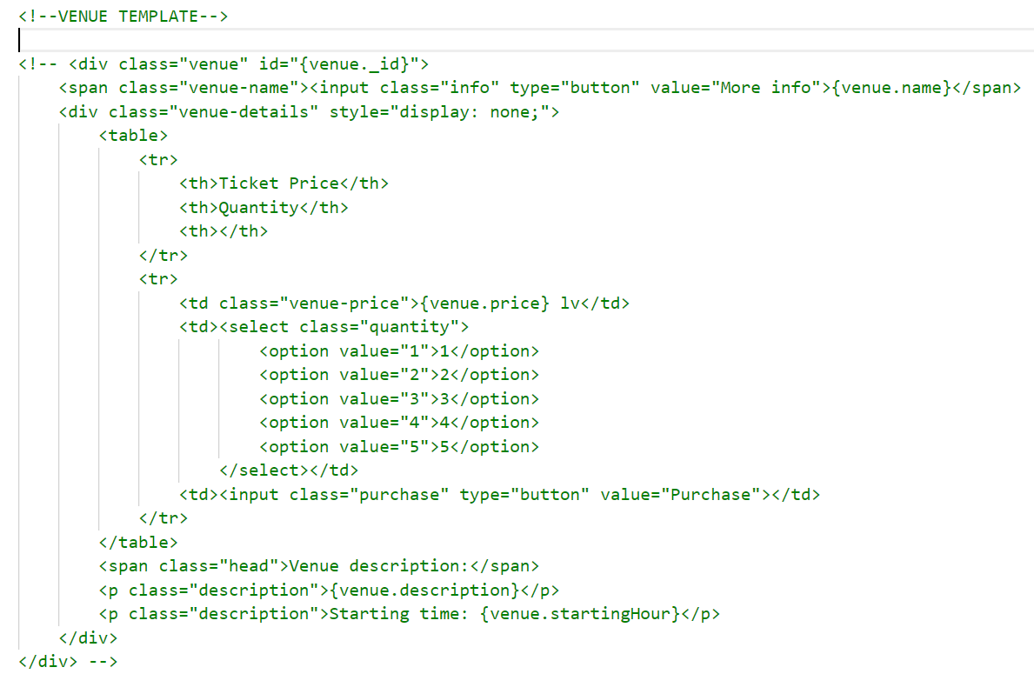

Each item in the list has a button **[**More info**]** that changes the visibility of the detailed description for the corresponding venue:

* Hide all descriptions (set style to "display: none")
* Show the current description (set style to "display: block").

The detailed view has a numeric drop-down and a button **[**Buy tickets**]**. When this button is clicked, take the user to the confirmation page - change the content of the "#venue-info" div, using the **comment confirmation template in htlm file.**

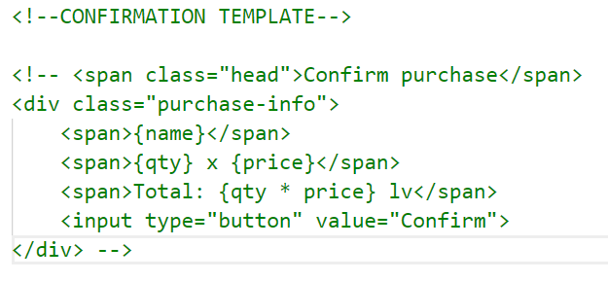

The final step is the confirmation of the purchase - when the user clicks on the button with ID "confirm", make a POST request to: rpc/kid_BJ_Ke8hZg/custom/purchase?venue={_id}&qty={qty}

The server will return an object, containing an HTML fragment in its html property. Display that fragment inside "#venue-info" along with the following text:   
"You may print this page as your ticket".

**Hints**

The service at the given address will respond with valid information for dates "**23-11**", "**24-11**", "**25-11**", "**26-11**" and "**27-11**", in this exact format.

**Examples**

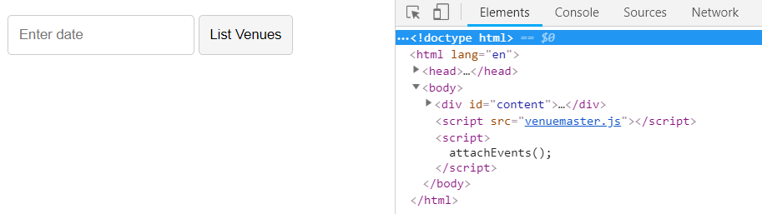

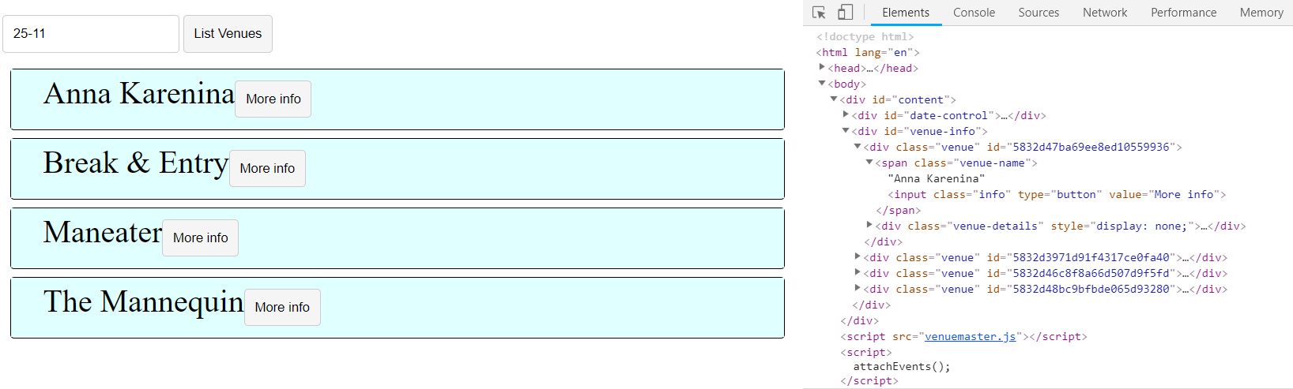

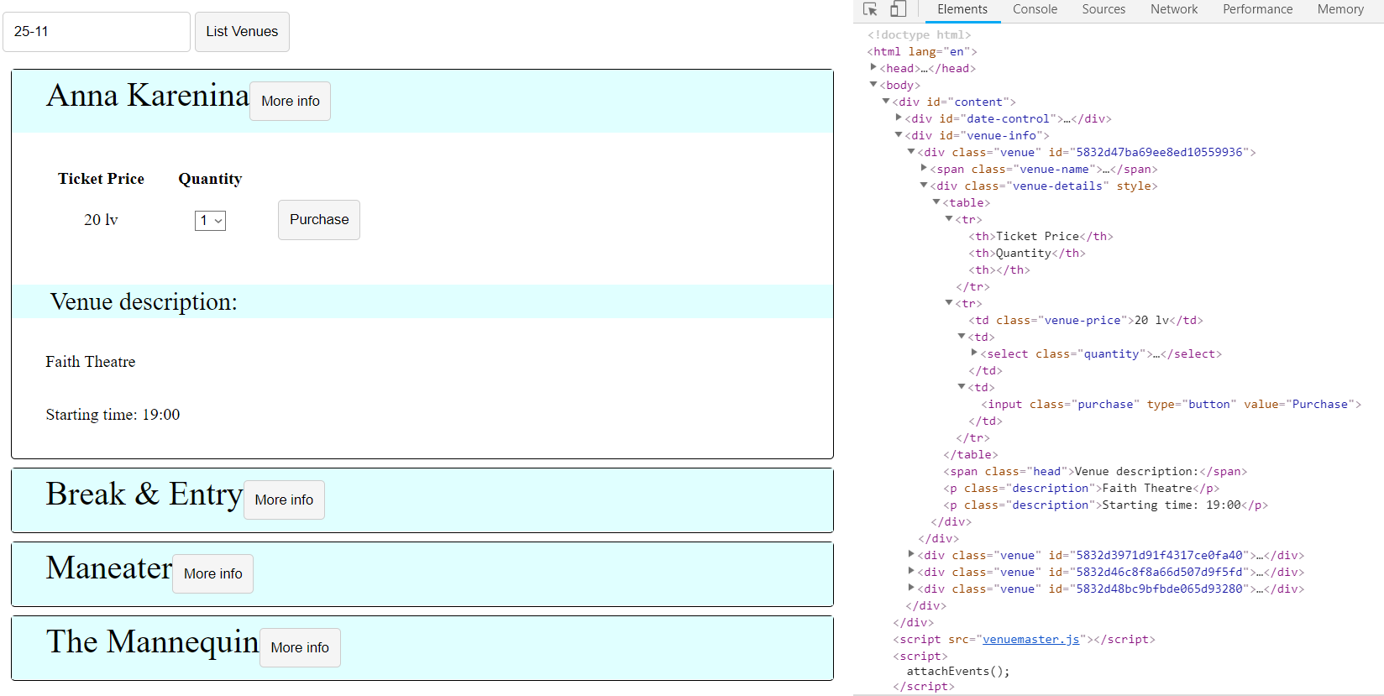

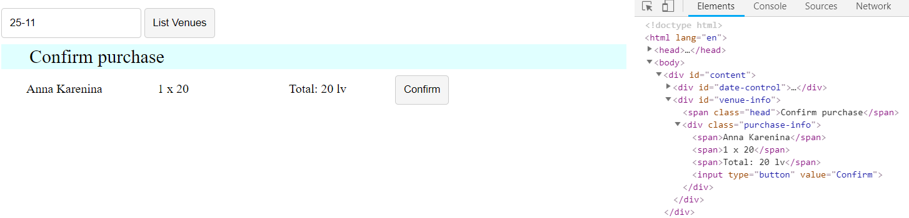

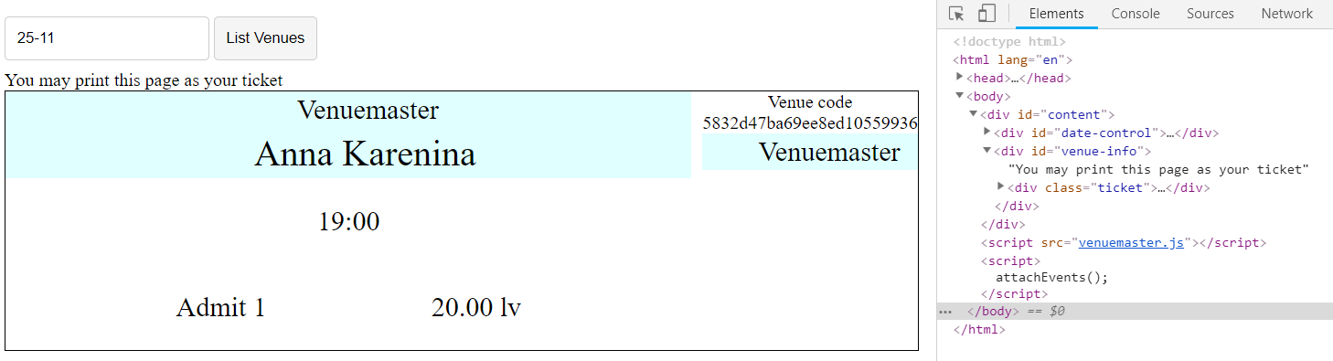

1. **\*\*\*Secret Knock (Not required)**

Your task is to perform the Secret Knock. The Secret Knock is a secret knocking technique that is performed with requests, responses and promises.

The credentials that you need to use for Kinvey database are:

* App id / key: kid_BJXTsSi-e
* App secret: 447b8e7046f048039d95610c1b039390

The guest user is:

* Username: guest
* Password: guest

You will need to **log in** before you perform any kind of action. Then you will have to send various requests **with queries** - a query is a list **of parameters added to the URL** of the request. Here is the base URL for the requests:

<https://baas.kinvey.com/appdata/kid_BJXTsSi-e/knock>

You have to add the first query, which is “Knock Knock” to the URL. It should look like this:

[https://baas.kinvey.com/appdata/kid_BJXTsSi-e/knock?query=Knock Knock](https://baas.kinvey.com/appdata/kid_BJXTsSi-e/knock?query=Knock%20Knock)

If you send a GET request to this URL, you will receive a response with an **answer** from the server, and the **next message**. Change the query with the **next message** in line, and continue this process until you receive a response **with no next message**. Print the **answer** and the **next message** after each successful request on the console.

1. **\*\*\*Wild Wild West (Not required)**

Write REST services for a simple Western game. Create a collection players (name, money, bullets) to hold information about the players in the game.

* name - string representing the name of the current player.
* money - integer number representing the current player’s money.
* bullets - integer number representing the current bullets of the player.

**HTML and JS**

You will be provided with a skeleton project containing an HTML template and some JS files. The loadCanvas.js is a simple implementation for the game and your job is to attach events to all the buttons and make the needed AJAX requests.

When the page is loaded a GET request should be sent to the server to get all players and load them in the **div** with **ID** **players**. An example entry is left in the HTML to demonstrate the representation of a player and their placement.

Whenever the [Save] button is pressed, the progress of the current player (if any) should be saved (a PUT request sent to the server with the new data):

* The **canvas** and buttons [Save] and [Reload] should be hidden
* The clearInterval should be called on the canvas.intervarId property (used for the main loop of the game)

Whenever the [Reload] button is pressed, the player’s money should be **reduced by 60** and their bullets should be **set to 6**.

Whenever the [Add Player] button is clicked, a new Player with the name specified in the corresponding input should be created and the players should be reloaded to display the new entry. Each new player **starts** with **500 Money** and **6 bullets**.

Pressing the [Play] button on a player should:

* Call the[Save] button
* Display the **canvas**, [Save] and [Reload] buttons
* Call the loadCanvas() function (from the loadCanvas.js)
* Pass to it the **new player** as an object (containing properties name, money and bullets)

When a player’s [Delete] button is pressed, the player should be deleted (both from the HTML and from the server).

**Examples**

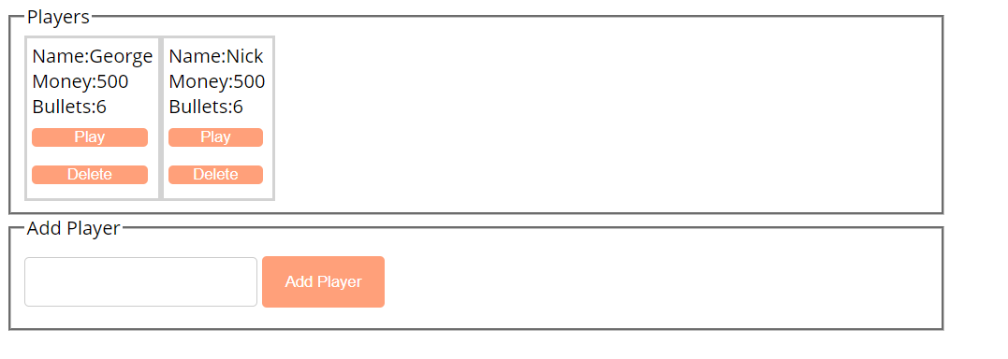

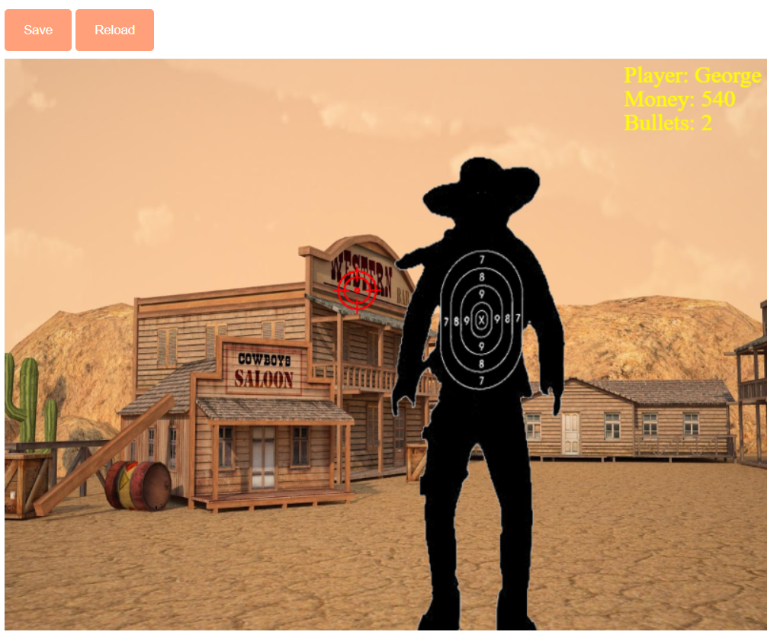

## Countries & Towns

### Create a Backend at kinvey.com

Register at **kinvey.com**, create an application and two classes: **Country(name)** and **Town(name, country)**. Fill sample data for further use. Submit in the homework screenshots of your classes from kinvey.com.

### List Countries

Create a JavaScript application (HTML + CSS + JS + jQuery) that loads and displays all countries from your application at Kinvey.com into a HTML page.

### Edit Countries

Extend the previous application with add / edit / delete for countries.

### List Towns by Country

Extend the previous application to show all towns when a certain country is selected.

### CRUD Towns

Extend the previous application to implement add / edit / delete for towns.